
Year 10 History Assessment 2: In-Class Source Analysis
Source Booklet
Source 1: Unemployment in the USA, 1929-33, created 1999.
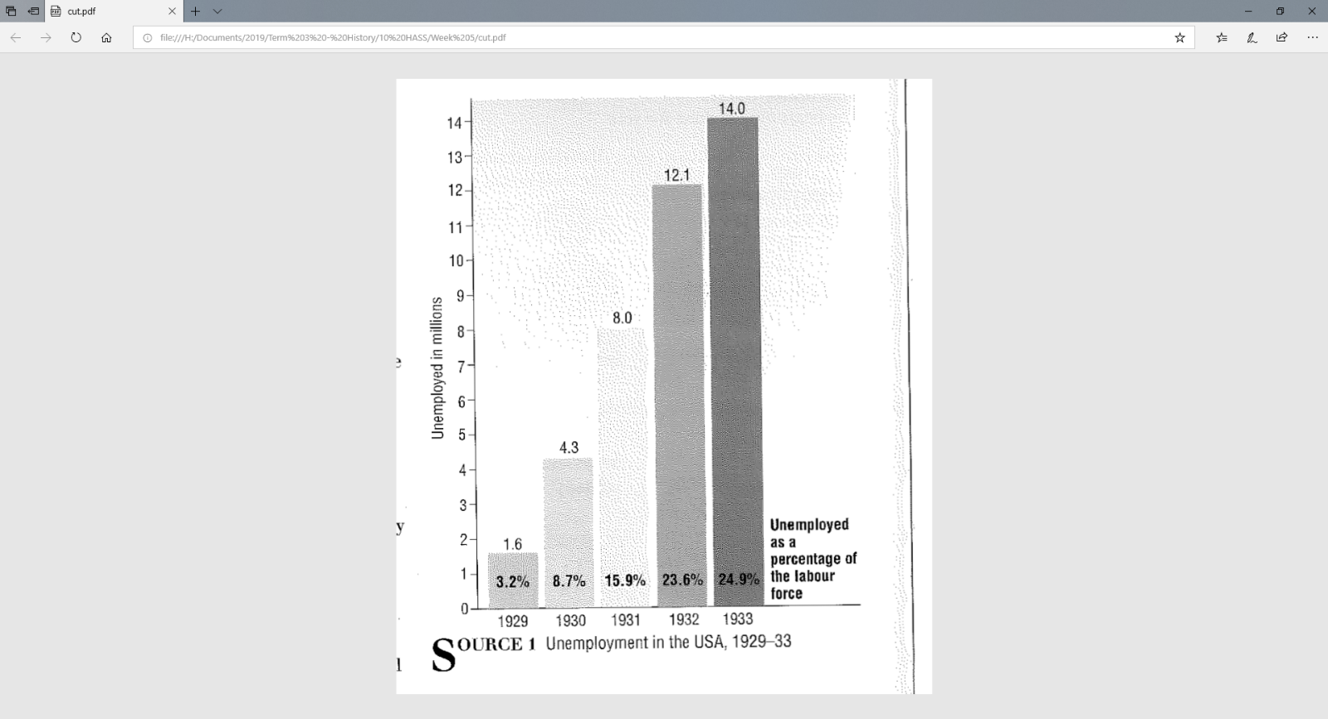

Source 2: From a speech by Australian Prime Minister, Robert Menzies, in The Sydney Morning Herald, 26th August 1939
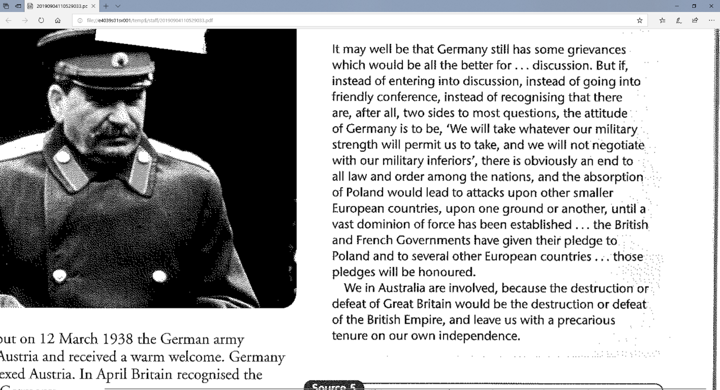

Source 3: Australian propaganda poster, 1941, He’s Coming South
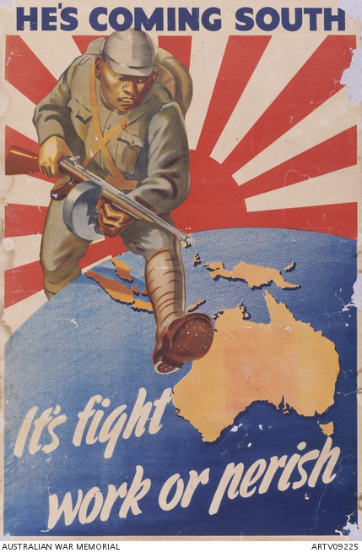

Source 4: A map of World War Two in Europe, 1941-1945, created circa 2017.
